Analysis of the Trip Advisor Dataset

Sage Hornung
Student/Author
PID A11532951
shornung@ucsd.edu
Bradley Furman
Student/Author
PID A11217454
bfurman@ucsd.edu
Matt Shaw
Student/Author
PID A11532887
mcshaw@ucsd.edu

ABSTRACT
In this paper, we will explore hotel reviews from Trip Advisor and find out if there is any pattern between some of the review feature categories and the overall rating of the hotel. We will create a simple baseline and then optimize the model by adding additional feature vectors and mining the text for additional information.

COMPUTING METHODOLIGIES
Machine Learning, Learning Paradigms, Supervised Learning, and Supervised learning by regression.
KEYWORDS
Hotel; regression; predictor; assignment 2; Trip Advisor; rating

INTRODUCTION

Initially I wanted to analyze NOAA data on the El Nino because of my great interest in the weather but I found the neural network model that was suggested to use for model optimizations slightly too complicated to fully understand in such a short amount of time. So ultimately decided to analyze the Trip Advisor dataset with a model to predict overall rating of a hotel using key rating features of a dataset including value, cleanliness, and sleep quality.

IDENTIFY A DATASET

The data we are studying for assignment 2 is a portion of a dataset found on online for Trip Advisor hotel reviews. This dataset has been has been previously analyzed and has a few scholarly papers that were written on the data. I am unsure exactly how large the original dataset was but there were roughly 275,000 reviews of 12,000 hotels across the United States with a small portion of international reviews mixed in. The original data contained roughly 12,000 files where each one represented a hotel and file contained a header with some basic information on the hotel such as Address, Price, Unique ID then followed any reviews that the hotel had line by line. In my initial analysis of the data I found there to be some hotels that contained zero reviews for some reason others had over five hundred. Because this assignment has time restrictions I created a sample by appending the hotel information to the end of each review and randomly selecting 100,000 hotel reviews from the original data so we now have a dataset containing 100,000 entries to use on our project. We plan on training on the first 50,000 and then validation on 25,000 and testing on the final 25,000. After some basic analysis I found we now contain a sample with 7819 different hotels having anywhere from 1 – 43 reviews. Each element in the dataset contains 7 integer-rating fields labeled as Service, Cleanliness, Value, Sleep, Rooms, Location and Overall Rating. These integer-rating fields contain a value of 1-5 stars with 1 being the worst and 5 being the best. There is also a text portion where comments can be made about the hotel. Each review also has the corresponding hotel information appended to the end of the review so we know. This dataset does contain empty fields but they are marked with a -1 to denote that the value was missing from the initial data. The initial analysis was conducted on a random sample of 60,000 reviews. The average number of words in a hotel review is 154 and the average rating for all categories including overall is fairly high in my opinion at around 3.5 to 3.8.
 | Total Stars | Out Of | Average Rating
Service | 202302 | 55477 | 3.64659228149
Cleanliness | 210786 | 55482 | 3.79917811182
Overall | 217800 | 60000 | 3.63110181311
Value | 195884 | 55600 | 3.52309352518
Sleep | 104110 | 26830 | 3.88035780842
Rooms | 177949 | 51102 | 3.4822316152
Location | 179140 | 48935 | 3.66077449678

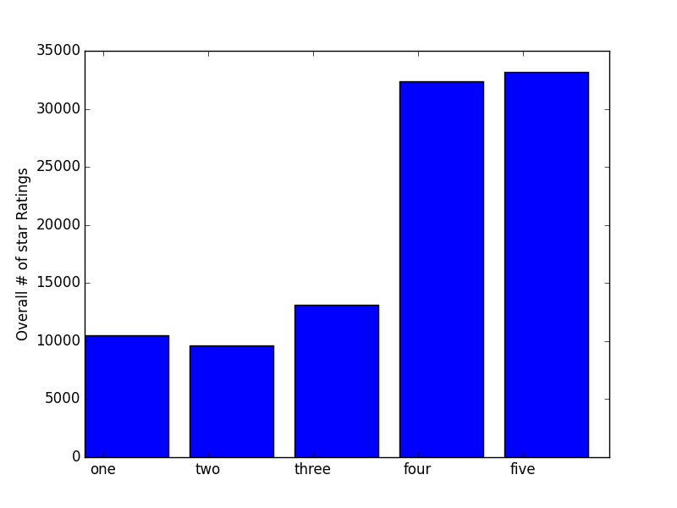
Overall star ratings for 100,000 reviews
Because there will be some fields are not guaranteed to be filled we can use either the average for that field from all hotels or infer an average based on the other reviews of that hotel. The lack of the field being filled could mean that the reviewer felt neither strongly or poorly towards that aspect or simply felt that that aspect did not have any effect on their rating. If a single attribute has this in common than we can say that not using such a feature will not have a major effect on the model and can exclude the feature due it potentially skewing results. We may also decide to remove hotels with very few reviews in case those ratings were affected by having a small number of reviews. Say a rating of 2 with only 1 review. That rating might not be accurate for that hotel given it is only a single person’s review especially if the overall rating for that review from the rest of the data shows the rating to be much higher than what is in our random selection of data. A model that we would likely come up with for this data is how cleanliness and sleep quality depend on the value when rating a hotel, meaning is value more important than cleanliness or sleep quality when a hotel is rated.

Looks like hotels are rated above average in general. I personally think that people are more inclined to review things when it is extremely good or bad and I believe this was shown to us in class. In general when searching things on Amazon or New Egg most products that contain a large number (a few hundred or more) of reviews are favorably rated.

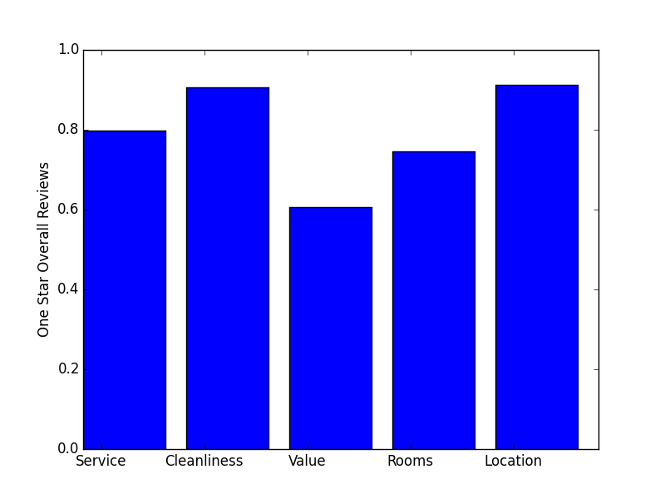
1 star overall category averages
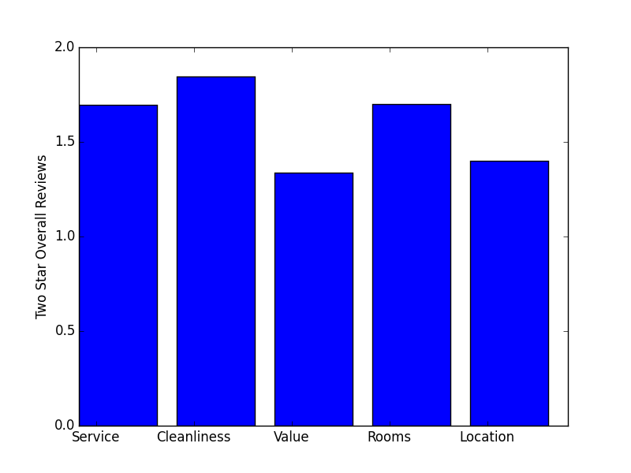
2 star overall category averages
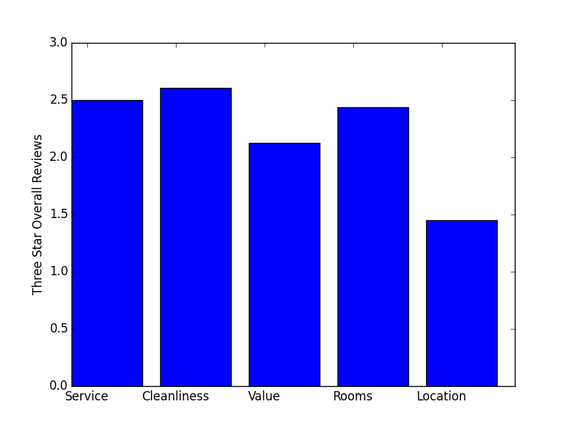
3 star overall category averages

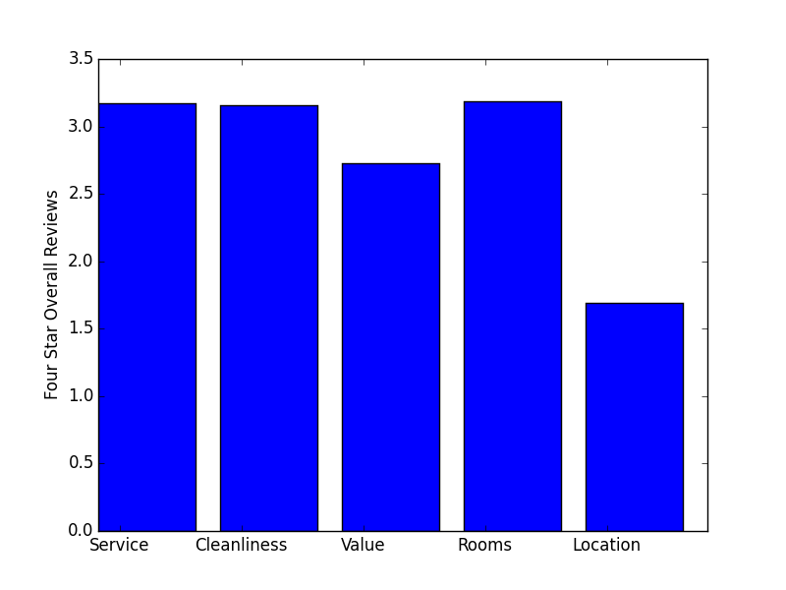
4 star overall category averages
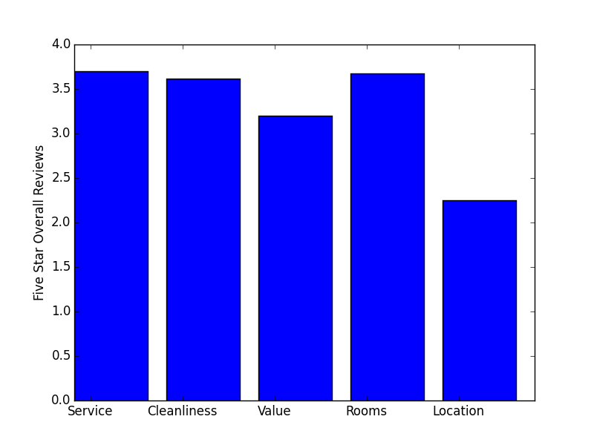
5 star overall category averages

IDENTIFY A PREDICTIVE TASK

There are a few predictive tasks that we can do on this dataset. We could predict the overall rating based on the sleep quality, cleanliness and price, or we could predict sleep quality or cleanliness based on the price alone, or predict price based on sleep quality and cleanliness. Baselines for these predictive tasks would be predicting the average every time whether it is the global average or the average based on data in the training set for that hotel. We will assess the validity of the models by getting the MAE of how the predictor does on a test set we create. We are using MAE in order to minimize the error any one prediction can cause so that if one is off by a lot it won’t affect the error as much. We will be using linear regression as our model since we are trying to find out how cleanliness and sleep quality affect the the overall rating or are affected by the price. We chose this model because it fits what we are trying to do in finding a relation between the models in order to make a predictor for unknown values. In order to test the validity of our model we will run it on a set aside amount of entries most likely from the number of reviews we did not use to make our smaller data set. We will run the baseline on that “test” set and compare our model to the baseline if it does better than we know our model is at least better than a worst guess scenario. From the results of that we can decide how we may optimize it. Optimizations that may occur could be including the text reviews or other rating fields from the dataset.

4. OUR MODEL

Linear regression was chosen as the model. Intuitively, it makes sense that most, if not all, of the different review fields in the data, such as “Sleep Quality” and “Cleanliness”, would have a direct impact on the Overall rating that a customer would assign a hotel; this model will reveal if they are linearly related. All features were scored by customers on a one-to-five scale; no scaling of features is required. This model is well suited to the data set; the features are not connected in such a way that a graph model would make sense, neither are there so many features that dimensionality reduction via PCA or clustering would be required.

With regards to program performance, the small number of features used and the size of the training and test sets did not cause any issues with scalability. Matrix and vector multiplications using the numpy library are already implemented well enough in Python that optimizing the model was focused on isolating the ideal features. A sizable improvement to the model’s accuracy came from rounding the final prediction. Overfitting seemed to begin to occur with incorporating aspects of the text as features; details provided in the results section.

One challenge with this data set is that, while all data entries supplied an Overall rating, many customers left one or more of the other rating fields blank. To ensure the predictor was trained correctly, only entries that supplied all features with a value were used for training. Initially, for entries in the test set that had missing values the predictor was not used; the Overall average was selected as the prediction. This was further improved by instead replacing the missing fields with values. Trial runs were performed with the missing fields set to zero or the average value for the respective field; the average value resulted in more accurate predictions than defaulting to a guess of the Overall average for the entry..
The initial chosen baseline was to calculate the average value for Overall and always guess the average. This resulted in a MAE of 1.0839. Adding the chosen features one-by-one resulted in a noticeable drop in the error each time, indicating their strong predictive power. The only exception to this was Location, which decreased the accuracy. Final feature selections and their respective predictive power are covered in the results section.

RELEVENT LITERATURE

There is a few of scholarly articles written on this dataset by Hongning Wang who used it by text mining and trying to predict people's opinion based on numerical rating and some relevant review text. By expanding on the Latent Aspect Rating Analysis or LARA with his own Latent Aspect Rating Analysis Model (LARAM), which he describes in his paper. In the paper Hongning Wang describes LARAM as “ a fully generative model for both the review text and the companion overall rating. Specifically, it is assumed that the text content describing a particular aspect is generated by sampling words from a topic model (i.e., a multinomial word distribution) corresponding to the latent aspect, the latent rating on an aspect is determined based on the words describing each aspect with latent sentiment polarities, and the overall rating is generated based on a weighted combination of aspect ratings where the (latent) weights reflect the relative emphasis on each aspect by the reviewer”.
Work that has been done on this dataset is Latent Aspect rating Analysis on Reviews by Hongning Wang in which the author used the review section of the dataset to determine the star ratings of other fields by determining the opinion of the reviewer. To do this they searched the text for aspect words then assigned a weight to them. The model they used is the expectation-maximization algorithm used for machine learning in order to get a model to be used on unknown data.

The literature [5] did a similar predictive task in which the authors predicted the overall rating of a hotel using this dataset. In order to predict the rating they used a neural network to analyze the text review field of the dataset. The task they were accomplishing is making a model to model language and acquire classifications from a text review.

The literature [6] also did a similar task to ours using regression as well. Their findings were that ratings vary by location and how many hotels are at a location, in addition the ADR(average price) of a hotel has a positive impact on the overall rating. While our method is similar to this literature we did not use average price in our model and incorporated other features in our model in order to get a different model, in addition to this their regression model is more focused around occupancy and number of hotels in a city than towards ratings based on the statistics of a given review.

What we are trying to do here is nothing new or exciting unfortunately. We are sticking with linear regression and many other basic models have done the same thing to predict ratings of a product or movie or a restaurant. One big advantage of a simple model is that it works well for a task such as hotel rating or something similar like a restaurant or a product somebody is buying because of its simplicity. If we are incorrect in our assumption there is only a minor inconvenience rather than say predicting if there is a bomb or a weapon in somebody's luggage. The simplicity also allows the calculations to be less computationally expensive and quicker which is a necessity on extremely large data sets.

CONCLUSION

The lowest attained error was 0.48654, much improved over the very naive baseline’s result of 1.0839. The final chosen features were, in order of predictiveness: Sleep Quality, Service, Rooms, Value using equation:

y = theta_0 + theta_1 * Sleep Quality + theta_2 * Value + theta_3 * Service + theta_4 * Rooms

Final values of theta:

[-0.03437857 0.32131342 0.17226782 0.21835196 0.28871837]

Several other features were trialled and benefited the accuracy little or were detrimental. Attempts to use aspects of the text all resulted in lower accuracy. Text features that were unsuccessful included the length of the text and a binary feature signifying that the text of the particular review was longer than the average, found to be 154 words. These features were useful in the helpfulness prediction of assignment 1, but there the focus was on determining the helpfulness of the review; apparently text features are less predictive when it comes to guessing the exact rating a customer gave an item unless you are doing a more intensive and complicated model such as the work done by Hongning Wang in which he analyzed the text for opinions.

Another unpredictive feature turned out to be the Location rating. This could be due to the ambiguousness of determining what exactly a “good” location is, or the location not being a significant factor when a person decides which hotel to stay at; a really great hotel being in a “terrible” location did not seem to affect a customer’s Overall rating.

Perhaps most surprising was the complete lack of predicting power the Cleanliness rating had; it’s theta value was 0.005, and it’s inclusion in the model had a trivial effect on the accuracy, leading to it’s removal. Apparently, a room being clean is not at all important to hotel guests, or if it is, it has nearly no effect on their Overall rating of the hotel. One hypothesis could be that the majority of people are not cleanly to begin with; it could also be that many people stay in hotels and make a much more of a mess of their room than they would their home, knowing that maids will be cleaning up after them regardless.

The feature with the biggest predictive impact was Sleep Quality. Customers that had a solid night of sleep rated the hotel much higher overall; ones who woke up on the wrong side of the bed, likely regardless of it being the hotel’s fault or not, took it out on the Overall rating.
What this implies for hotel owners is simply that if you want to get better ratings than make sleep quality a higher priority than cleanliness. As far as how successful our model is, we would say it is fairly successful considering that the error can be heavily dependent on a person's opinion, not only that but some parameters are not necessarily independent of each other even if they do have separate fields in dataset. Other models were not as successful mainly due to the fact that this task is not a binary predictor but one that involves predicting a range of values and while SVM and logistic regressions are focused on binary outputs they would not work well with the dataset without modifying the data in order to use as a predictor. What this means is that while the other models may not fail they are more expensive to train as compared to the linear regression in which you can use theta values to get a prediction on the rating.
This is a semi relevant side note I figured out while doing this assignment. My wife complains how bad the book predictions are for her on Amazon. She reads a lot of Sci-Fi and probably buys around 20 books a month from Amazon. The best predictor you could come up with for my wife's book purchases is if the category is Sci-Fi she will buy it otherwise not purchase. I realized they don't care about what books they should suggest her to buy, as they already know she will buy something and they simply suggest the remaining Sci-Fi books she has not purchased on Amazon. I assume she fits in the outlier category and they probably discard her purchase history to better fit the masses that may purchase something rather than suggest something to somebody they know will buy something. Figuring out a rating system that works for everyone would be extremely complicated and it would probably be better to categorize people first by how much buy in some sort of hierarchical clustering scheme then make multiple simpler models to make purchase predictions for them

REFERENCES
- Hongning Wang, Chi Wang, ChengXiang Zhai and Jiawei Han.Learning Online Discussion Structures by Conditional Random Fields. The 34th Annual International ACM SIGIR Conference (SIGIR'2011), P435-444, 2011.
- Yue Lu, Hongning Wang, ChengXiang Zhai and Dan Roth.Unsupervised Discovery of Opposing Opinion Networks From Forum Discussions. The 21st ACM International Conference on Information and Knowledge Management (CIKM'2012), p1642-1646, 2012.
- Hongning Wang, Yue Lu and ChengXiang Zhai. Latent Aspect Rating Analysis without Aspect Keyword Supervision. The 17th ACM SIGKDD Conference on Knowledge Discovery and Data Mining (KDD'2011), P618-626, 2011.
- Hongning Wang, Yue Lu and Chengxiang Zhai. Latent Aspect Rating Analysis on Review Text Data: A Rating Regression Approach. The 16th ACM SIGKDD Conference on Knowledge Discovery and Data Mining (KDD'2010), p783-792, 2010.
- Marcheggiani, D., Täckström, O., Esuli, A, Sebastiani, F.: Hierarchical Multi-Label Conditional Random Fields for Aspect-Oriented Opinion Mining. In: Proceedings of the 36th European Conference on Information Retrieval (ECIR 2014).
- Wang, H., Lu, Y., Zhai, C.: Latent aspect rating analysis on review text data: A rating regression approach. In: Proceedings of the 16th ACM SIGKDD International Conference on Knowledge Discovery and Data Mining (KDD 2010). pp. 783–792. Washington, US (2010)
- Evan Shieh, Alex Zamoshchin. Modeling Hotel Quality Belief in Natural Language Reviews.
https://cs224d.stanford.edu/reports/ShiehEvan.pdf
- Wanchen Yu. The effects of hotel performance characteristics on customer online ratings
http://lib.dr.iastate.edu/cgi/viewcontent.cgi?article=5001&context=etd, 2014.

