ACM Word Template for SIG Site

Ricky Chen
Data Mining and Predictive Analytics
University of California, San Diego
9500 Gilman Drive, La Jolla, CA 92093
Ryc010@ucsd.edu

ABSTRACT

In this experiment, we analyze and try to create a prediction model that can accurately determine if a user in Amazon is helpful or not. Each review a user leaves has a helpfulness rating of how many people thought the review was helpful out of everyone who rated the review. However, this helpfulness rating by itself isn’t sufficient enough to accurately predict if a user can be categorized. Through this experiment, we try to discover what features of a user and their reviews can help to improve the accuracy of whether or not a user can be categorized as helpful.

INTRODUCTION

Amazon’s marketplace is one of the most widely used online shopping centers. This is due to excellent user interface features that make it extremely convenient for other potential buyers to learn about products and obtain testimony from others who have already purchased the item in question. On top of that, Amazon spotlights reviews that have high ratings and categorizes them into both positive and critical(negative) reviews.
Amazon has a reviewer rating that is based on a users overall helpfulness; however, we will attempt to see if we can determine a better recommendation system. The results from this experiment will not be conclusive due to the fact that we do not have the actual reviewer rating data in this data set but will be formed based on the comparison of our data sets to reasonable baselines to ensure that a fundamental accuracy was maintained and that there is a difference between our potential recommendation system and the simple set of users based purely on the overall helpfulness percentage.

DATASET DESCRIPTION

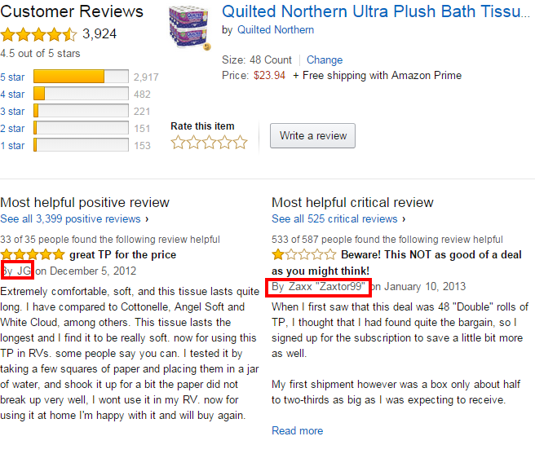

The data set I chose to perform an analysis on was a set of Amazon reviews about Health and Personal Care products. Each entry in the data set had the following properties: reviewerID – ID of the reviewer, asin – ID of the product, reviewerName – name of the reviewer, helpful – helpfulness rating of the review(e.g. 2/3), reviewText – text of the review, overall – rating of the product, unixReviewTime – time of the review in unix time, reviewTime – time of the review in raw format. I only used a random set of 5000 reviews. The 5000 reviews cover from March 2003 to June 2013 with the average review rating being 3.29103. Something I noticed about this data was that it had some fake reviews so I filtered those out by filtering for the string “Fake!” Membership was calculated by using a user’s oldest reviewTime and subtracting from July 1, 2014 since that was the noted time of the data collection from the source of the data set.

Model Selection

The predictive task I am trying to evaluate builds upon the helpfulness prediction task from the first assignment. However instead of just predicting if a user’s specific review will be helpful, I will attempt to create a threshold of ranking for reviewers. Then given a user(not a specific review of the user’s) I will predict whether we can expect the user to be helpful if a review is found for an item with that user as the author. I will be using similar relevant baselines to task 2 in assignment 1 where the baseline was the global average helpfulness rate or the user’s rate if the user was in the training data. Users will be ranked with a simple binary system with a 1 indicating they write useful reviews and 0 meaning they don’t. In order to assess the validity, I will compile a set of user’s who are in the bottom 25% of users who have an average helpfulness rate that’s below the global average helpfulness rate Another set I will compile is users who are in the top 25% of users who have an average helpfulness rate that’s over the global average helpfulness rate. These two sets should help to ensure that not only are useful reviewers being accurately predicted but reviewers who are not useful are not being mistakenly categorized as useful.

Evaluation will be done using a combination of simple feature filters such as we did in task 2 originally as well as based on frequency of using n-grams associated with high helpfulness. The data set will need to be split into reviewers who are very active and different thresholds will be used for each set. The reason for using n-grams is because users who frequently write helpful reviews should be expected to go into depth about the certain features which would be directly correlated with why they received high helpfulness ratings. One feature I had to be careful about weighing was length of the review, since I didn’t want to establish the strict correlation that a long review automatically implied that it was useful due to my personal experiences of reading lengthy and useless reviews especially when filled with quotes directly from the product description.
Other features that will be evaluated include popularity of the item(not overall rating but instead purchase count), length of membership of the reviewer and overall rating of the item itself. The reason for separating purchase count and overall rating is to account for situations where items are purchased based on “brand” or “popularity” even though the overall ratings are low, where reviewers are generally more scrutinized based on the content of the review since they have to strongly justify why they are for or against a specific item.

RELATED LITERATURE/STUDIES

The data set I analyzed was produced by the Professor. The data was used to determine which products were complementary and substitutable with each other. Other datasets that are similar include reviews on Amazon in other categories of items. One of the most well-known rankings that are similar to this is the Elite Yelper status. Yelp has not officially released the method for determining how one achieves this status and it could even be an individual holistic case-by-case basis with no actual predictor system(although doubtful due to its incredibly dense userbase).

Similar datasets that have been studied include all the clothing reviews from Amazon that was the basis of our first assignment and from which much of this experiment was based on

One piece of useful literature that I researched into, aside from the Professor’s own writing which produced this dataset derived results from it, was a paper by Minqing Hu and Bing Liu of the University of Illinois at Chicago titled “Mining and Summarizing Customer Reviews”. The approach they took was more thorough than mine. In summary, they took user reviews, mined which product features were mentioned in each review, as well as deciding which statements in a review were positive or negative and then they explained their findings. The system they used has been dubbed Feature-Based Summarization. Their article can be found at this link: http://www.cs.uic.edu/~liub/publications/kdd04-revSummary.pdf. The most interesting part of this literature was how compartmentalized each part of the data mining was(Refer to figure below)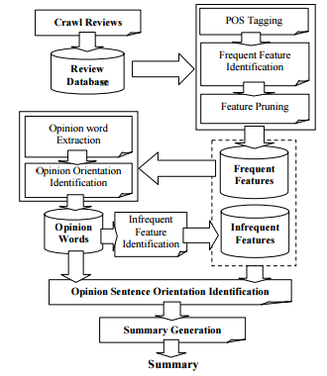
Although their system is not directly related to the ranking of users which I evaluated, the feature mining from each review was an interesting concept that I would be interested in exploring and possibly implementing into my own system for ranking users. It is reasonable to form the conjecture that users who frequently identify specific product features in their reviews would generally have more helpful reviews although more analysis would be needed in order to be able to derive how strong this correlation is.

Another interesting article that also observed features was a paper written by Jiangye Wang and Heng Ren from Stanford University. Their paper can be found at the following link
http://nlp.stanford.edu/courses/cs224n/2007/fp/johnnyw-hengren.pdf

The main take-away of this paper was the Pointwise Mutual Information algorithm which determines how much mutual information is shared between the two words. This is an extreme refinement of the n-gram system that I implemented which was just a basic weighing of bigrams(minus stop words).
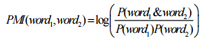

RESULTS
Through simple feature filters we were able to improve the accuracy of our predictor being able to determine which users were helpful vs. which were not.
Features Considered | %_1 | %_2
Helpful & membership | 0.93653 | 0.0513
Helpful & membership & overall rating | 0.93215 | 0.0234
Helpful & membership & overall & n-grams | 0.93114 | 0.0155
Helpful & membership & overall & n-grams & popularity | 0.95416 | 0.0432
Helpful & membership & n-grams | 0.91231 | 0.0355

%_1 indicates what % the set of helpful users was compared to the set that included the top 25% of users
who have an average helpfulness rate that’s over the global average helpfulness rate. %_2 indicates what % of users from the helpful users set was in set of users that had were in the bottom 25% of helpful users(therefore lower % is better). Features considered show which features were considered and used to filter the set of helpful users.

From these results we can determine that filtering using helpfulness, membership length, overall popularity of item, n-grams and popularity generated the most accurate model in terms of which users had high helpfulness ratings from the baseline compared to the set of users created from the filters.

who have an average helpfulness rate that’s over the global average helpfulness rate. %_2 indicates what % of users from the helpful users set was in set of users that had were in the bottom 25% of helpful users(therefore lower % is better). Features considered show which features were considered and used to filter the set of helpful users.

From these results we can determine that filtering using helpfulness, membership length, overall popularity of item, n-grams and popularity generated the most accurate model in terms of which users had high helpfulness ratings from the baseline compared to the set of users created from the filters.

CONCLUSION

This experiment is slightly counter-intuitive because we would assume that helpful percentage is not enough to accurately determine how helpful a user is. Through my personal experience using Amazon, some users who have extremely high reviewer rankings and helpful percentages have extremely unhelpful reviews. Although I am unable to compare my percentages to the actual reviewer ranking system that is compiled by Amazon, it is obvious to me that the system is not as rigorous as it could be for determining helpful users. Through the features I explored and with further refinement, I believe this could develop into an automated system where reviewers could be truly recognized for writing helpful and great reviews and eventually Amazon could implement a system that recognizes these users(much like Yelp’s Elite Yelpers).

