Predicting Income with Classification
The goal of this paper is to analyze a large data set with predictive analytics and past research on similar methods or topics. After working long and hard with one book review data set that seemed to have no interesting findings, I decided to switch it up completely and start over with a new data set on census income. The information was extracted from the 1994 Census database and can be found online in the UCI database repository; it is entitled “Adults” and contains 15 attributes with 48,842 instances. The attributes, their variable type, and their different categories are listed in the table below.

AGE | WORKING CLASS | FNLWG | EDUCATION | ED. # | MARITAL STATUS | CAP GAIN | SEX
Cont. | Categorical  Private  Self-Employed  Local Gov  State Gov  Federal Gov  No Pay  Never Worked | Cont. | Categorical  High School  Some College  Bachelors  Masters  Vocational  11th  Assoc Academ.  10th  7-8th  Prof. School  9th  12th  Doctorate  5-6th  1-4th  Preschool | Cont. | Categorical  Married-civ-spouse  Never Married  Divorced  Separated  Widowed  Married-AF-Spouse  Spouse Absent | Cont. | Cat.  Male  Female
CAP LOSS | RACE | COUNTRY | RELATION | HOURS  WORK | OCCUPATION | INCOME
Cont. | Categorical  White  Black  Asian-Pac-Islander  Amer-Indian-Eskimo  Other | Categorical  42 Countries | Categorical  Husband  Not in Family  Own Child  Unmarried  Wife  Other Relative | Cont. | Continuous  15 Occupations | Cat.  <=50K  >50K

One of the attributes that is not as self-explanatory as the others is “Income”. This variable includes the values “<=50K” and “>50K” which refers to the amount the person of the row makes in thousands per year. Additionally, “Working Class” describes who the person works for (government, self-employed, etc) while “Occupation” specifies the actual job the person holds. In order to make sure I was working with clean data, I took a subset of the initial data in which I eliminated any rows with missing values. This left me with 30,163 instances to perform analysis on. In terms of a predictive task, the data set was generated in order to predict, given the certain features of the person, if the person’s income was less than or equal to 50K or greater than 50K. With this possible hint in the back of my mind, I wanted to see if such a predictive task would be possible. My natural first instinct was to get the basic statistics behind the data.
The very first variable I observed was “Income”. In order to perform classification with income as the dependent variable, it is important that there are enough observations for both of the factor levels in “Income”. I found that 22,655 instances have a value of “<=50K” while 7,509 instances have a value of “>50K”. Since the number of instances for greater than 50K is significantly lower than the number of instances less than or equal to 50K, it seems like a classification involving income would be one that predicts if the person has an income greater than 50K. This is because a model that predicts an outcome that is more likely to occur could be deemed as good whether it truly is or not (The true predictions could just be deemed from chance). With the predictive task clearer, I decided to look at the features what would help determine my outcome.
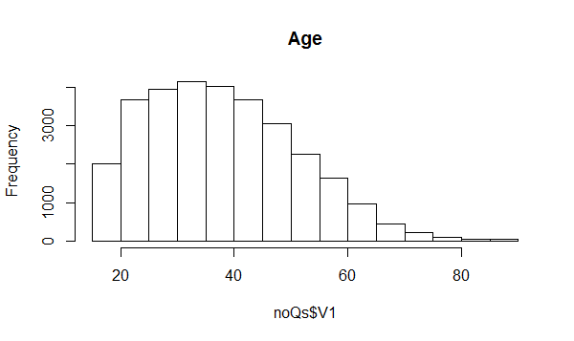
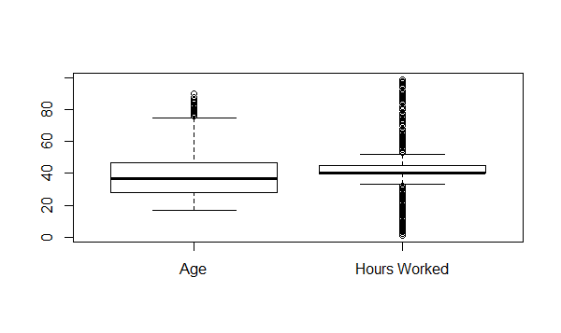
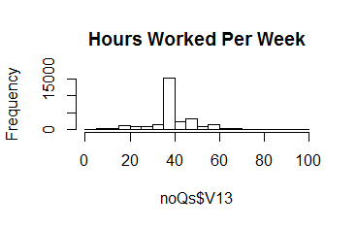
Two of the first features I observed were “Age” and “Hours Worked” per week. I created both histograms and boxplots to get a feel for the distribution of the variables. While the age of the respondents seemed to have a more normal distribution with relatively few outliers (the mean is 38.44 and the median is 37.00), the number of hours worked per week was a little less varying, but the outliers that existed were more extreme (the mean is 40.93 and the median is 40.00). These recognitions hint that age may be a better feature to use for a predictive task because it is not as constant as hours worked is.

I next observed the numerical features that were left and compared them with the two possible income categories. As one would expect, the age and education number are positively correlated with an income of greater than 50K. This is supported by two boxplots on the top of the next page. I have also included a scatterplot on both the “Capital Gain” and “Capital Loss” vs “Income” just to give a full sense of the features being used. However, the results do not seem too interesting in terms of our task at hand.

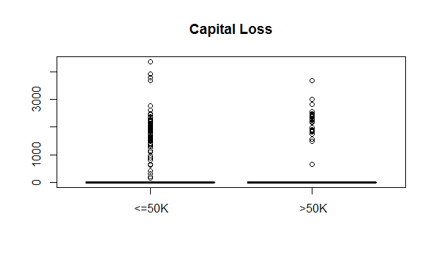
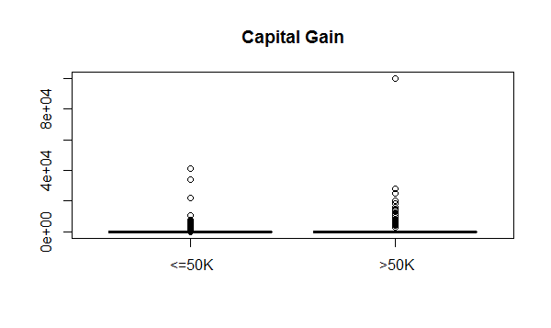
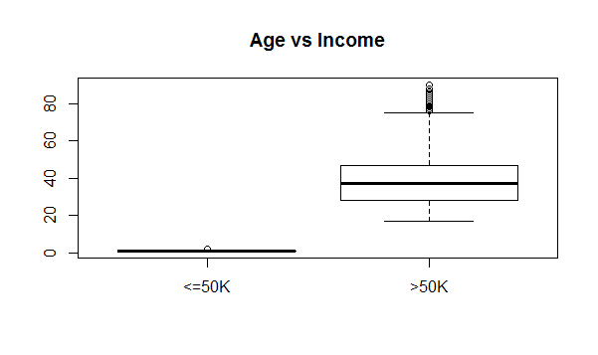
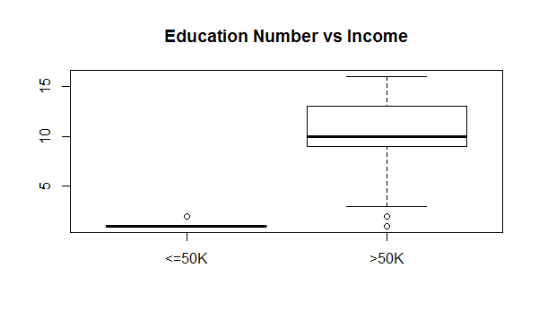

The final step I took in my exploratory analysis was looking at the statistics behind marital status and race. Below are the summaries (counts) from R Studio of both variables. Since there were an overwhelming amount of “Married” marital status’ and “White” races, I decided to check the intersection of the two to get a better feel for the main “person type” of the data. Out of the 30,163 instances, it was found that 12,938 were married and white. In terms of classification, this distinction could either be very helpful in determining the income if the correlation between income and the married, white person is close to 1 or -1. However, it does no good if there is no significant correlation.

MARITAL STATUS
Divorce Married Never-m Separated Widowed
4214 14456 9726 939 827
RACE
Amer-In Asian-P Black Other White
286 895 2817 231 25933

With that noted, I decided to perform regression with income as the dependent
variable and marital status and race as the independent features. The results were
interesting in the sense that the “Married” coefficients were the greater of the marital
status coefficients, yet “Asian-Pacific-Islander” had the greatest coefficient for race. “Asian-Pacific-Islander” had a coefficient of 0.120092 while “White” has a coefficient of 0.105772. Even though “Asian-Pacific-Islander” has the highest coefficient for race in determining income, it does not help much because there are only 895 total Asian-Pacific-Islanders in the whole data set. This means that if I were to use Asian-Pacific-Islander as a main classifier, I would not get impressive results because it would only be significant for a small amount of instances. Thus, I decided to perform regression on income with some of the other features as well, and I provided the results in a table on the next page. With those basic statistics guiding me, I decided to start my attempt at classification for income.

Top 4 Correlated | Categories of Each | Feature
 | Age
Age | 0.007967
 | Sel-emp-inc | Private | State Gov | Self-emp-not-inc
Worker Class | 0.1716 | -0.16827 | -0.1181 | -0.10135
 | Prof School | Doctorate | Masters | Bachelors
Education | 0.677126 | 0.674715 | 0.492277 | 0.34954
 | Married-AF-spouse | Married-civ-spouse | Never Married | Seperated
Marital Status | 0.36893 | 0.3477 | -0.05894 | -0.03697
 | Exec-Managerial | Prof-Specialty | Protective Serv | Tech Support
Occupation | 0.351385 | 0.314654 | 0.192252 | 0.17099
 | Own Child | Other Relative | Unmarried | Not in Family
Relationship | -0.44134 | -0.4163 | -0.38935 | -0.34915
 | Asian-Pacific-Island | White | Black | Other
Race | 0.15821 | 0.14484 | 0.01104 | -0.02797
 | Male
Gender | 0.2002
 | Hour
Hours Worked | 0.008283

For my predictive task, I will be creating a classifier as my model in order to
determine if a person makes an income of more than 50K a year. In order to make sure I
have enough instances in my training set, I will use 3/4 of the data set on training and 1/4
of the data set on testing. However, I will compute the error rate 4 separate times by using K-4 Cross Validation and then use the average of this error for my model. After analyzing
the basic statistics behind the dataset and noticing that the factor levels for income are
not close to a 50/50 split, a “chance” baseline where I just predict half of the people have an income above 50K and half have one equal to or below 50K does not make sense. Thus, I have decided that an acceptable baseline could be created initially from the feature “Education”. I will predict a “1” for income being greater than 50K if the education level is “Some College” or above (ie the “Education Number” is 10 or above) and a “0” if not. This makes a prior-knowledge assumption that
those persons with less of an education do not make as much money as those with higher education may. Of course, this is just the baseline and we will alter the model based off of the training data to beat the baseline.
In order to beat the baseline, I will first regress on income with marital status and race as the dependent variables each time I want to train the data. This idea came to me when I was performing the basic statistics on the data set. Once I have done so, I will grab the highest coefficient for the factors in marital status and likewise for race. Then, using these two factors, the new model will predict a “1” for an income greater than 50K if the person is of the same race and marital status as the grabbed ones and will predict a “0” if not. I will be able to compare future possible models using the error computed by hamming loss and the false negative score. Another possible addition to my model will be implementing certain checks based off of the Jaccard similarity between certain factor levels and income greater than 50K. For both the regression and Jaccard similarity, I will need to create dummy variables to represent the categorical features. The dummy variables for regression and the dummy variables for the Jaccard similarity will differ, however, because while the regression requires our vectors to be interdependent meaning we essentially leave out the last index feature, the Jaccard similarity is going to be performed for each factor level of the feature against income. By classifying income based on the features that relate closest to income, I will essentially be using a Naïve Bayes model because the correlations correspond to the probability that the income is greater than 50K given the certain feature tested. The ideas I have on implementing my classifier are a little different than some of those that I read about online.
As mentioned in the opening paragraph, I found my dataset on the dataset repository for University of California, Irvine. The donors were Ronny Kohavi and Barry Becker and I provided the link at the end of the paper for where the data was extracted. On the data set description, the description actually mentions that the point of the dataset was to determine if a person’s income was greater than 50K based off of the other 14 attributes. The description also mentions error rates found using different algorithms such as nearest neighbor, NbTree, C4.5 (decision tree algorithm), and CN2 induction. Additionally, a link was provided to a paper that references the data set.
“Scaling up the Accuracy of Naïve-Bayes Classifiers: A Decision Tree Hybrid” is an article written by Ron Kohavi and describes a hybrid approach to classification. In the article, he recognizes that while the Naïve-Bayes method can sometimes work well on smaller data that does not necessarily follow the independence requirements, it does not have the same outcome when data is larger. However, the simplicity is attractive. Thus, he introduces a method that combines decision trees with Naïve Bayes: the NBTree method. In this method, the leaf nodes are the segmented data and actually described by Naïve Bayes classifiers. The goal of is to try to approximate if the Naïve Bayes classifier at each leaf has a better accuracy than the current leaf node. Since runtime and complication increases with the number of splits in each tree, only splits with at least a 5% reduction in error and with at least 30 instances in the node are considered important. In addition to the article I found by Kohav, I managed to find a thesis paper by a student from Institute of Technology, Blanchardstown under supervisor Markus Hoffman whom described his attempts at a model of the “Adult” dataset. Like Kohavi, this student used Naïve Bayes and Decision Tree classifier in his model; however, he also included kNN and Rule Induction Classifier in his mix as well. Interestingly, his basic analysis of the data included regressing on income with each feature just as I have done and his process of forward selection was implemented in his model just as it was with mine. His results on significant features were relatively similar to mine (ie we both found that “Country” seemed to have little correlation with income and that “Marital Status” and “Education” –categorical and numerical- were highly correlated with income.
Additionally, there are other similar datasets to that of the “Adult” dataset that have been analyzed and used for predictive tasks using user demographics. The Historical Census Population dataset was derived from London’s census data and has been used to predict the population amount of London between the years 1801 to 2001 while the real world data from the IGMC blood bank has been used to predict if a person is a blood donor or not based on their demographics. Another interesting dataset that involves classification is the Contraceptive Method Choice Data Set from the UCI repository. This dataset has been used to predict what type of contraceptive a woman will use based on the information (features) of the wife and husband of the instance. These datasets, along with many others regarding classification, have been studied using certain state-of-the-art methods that involve decision trees or probabilistic models. Examples of such methods include Naïve Bayes classifier (of which I have found to be one of the more common approaches), C4.5 (decision tree classifier), K-means algorithm, K-Nearest Neighbor, support vector machines (SVM), CART (Classification and Regression Trees), and the Prism Algorithm.
After running the baseline of my model on my test set, I received a hamming loss error of .5258 which is definitely not an ideal hamming loss error for any model. In order to improve this rate, I then included “Marital Status” and “Race” into my model. I predicted “1” if a person was married and white and “0” if not. This lowered my error rate down to .2538 which was still not ideal. Thus, I reverted back to my chart full of regression results to pick my feature checks more wisely. This is when I got the idea to check if the “Relationship” category was “Own Child”. If true, I predicted that the person does not make greater than 50K since there is such a high negative correlation between income and “Own Child”. Unfortunately, this change of model only decreased my error rate by .14. I continued to create different Naïve Bayes classifier instances in order to possibly better my model, but the best hamming loss error rate I received was .2524. Even when I implanted my Jaccard Similarity with “Education”, the results of my error rate rose back up.
The features that worked best in my model were “Education”, “Occupation”, and “Relationship” which is in accordance with the results of the thesis student mentioned prior. It seems that those who are married with a higher education and work as an executive or in a more professional occupation are more likely to have incomes greater than 50K. In terms of poor features, “Age” and “Hours Worked” were among the weaker ones because they gave no influence to the model’s accuracy. “Gender” was also a poor feature to work with because nearly 2/3 of the dataset were male and there was not a significant correlation between income and gender. In comparison to other models used on this dataset and created by other data scientists, my model is very weak. This does not surprise me, however, because the methods they implemented were mixed models and not only based on Naïve Bayes. The good thing about my model is that it did not fall subject to over-fitting the data; I was able to confirm this with the K-4 Cross Validation because the average errors computed were all within a close range of each other.
I believe that if I were to have been able to implement a decision tree while using the feature checks I created in my model, my results would have been much closer to those of other models. That being said, I would have had to do a lot more research to actually be able to correctly implement such a tree because the level of sophistication seems a little too far out of my realm of knowledge as a new data analyst. Although my model is not as advanced as others before me, the failure of this model just encourages me to learn more about other possible implementations used on similar datasets and work harder to become a better data scientist.

LINKS USED:
UCI Repository:
http://archive.ics.uci.edu/ml/datasets/Adult
Top 10 Algorithms in Data Mining:
http://www.cs.umd.edu/~samir/498/10Algorithms-08.pdf
Blood Donor Paper:
http://www.ijarcsse.com/docs/papers/Volume_4/6_June2014/V4I6-0259.pdf
Student Thesis:
http://www.dataminingmasters.com/uploads/studentProjects/Earning_potential_report.pdf
“Scaling up the Accuracy of Naïve-Bayes Classifiers: A Decision Tree Hybrid” by Ron Kohavi:
http://robotics.stanford.edu/~ronnyk/nbtree.pdf

