Predicting Online Auction “Robot” Bids through Data Mining
John Oliver Mendoza
A10301538
CSE190 Data Mining Assignment 2
UCSD

1 Dataset
Kaggle is one of the largest platforms for predictive modeling and analytics and works directly with companies and researchers to create competitions for the best models given a certain dataset. The dataset that I will be looking at is from a Kaggle competition hosted by Facebook, which asks competitors to look at the online auction data and identify which of the online auction bids are placed by “robots”. Facebook and Kaggle has worked together and created this competition in order to prevent unfair auction activity. The data separated into two sets: one is a bidder dataset that includes a list of bidder information such as their id, payment account, and home address. The other dataset is a bid dataset that includes 7.6 million bids on different auctions. It is worth noting that all of these bids are made from mobile devices and so some of the fields are mobile phone specific. The bidder dataset is separated into two parts: the training set and the test set. These two sets are a csv file with each line as a new record entry. Each line contains the following fields: a bidder_id, payment_account, address, and outcome. The ‘bidder_id’ is a unique idenitifier of a bidder. The ‘payment_account’ is associated with a specific bidder and is obfuscated to protect privacy. The ‘address’ contains an obfuscated mailing address of the bidder. The ‘outcome’ field labels the bidder as either a robot or a human. A value of 1.0 means you’re a robot and 0.0 indicates that you’re a human. The training set is contains 2014 lines which each line containing a unique bidder_id. The training set contains 4701 lines which each line containing a unique bidder_id. The other dataset is the bid dataset, which contains 7.6 million records and has the following fields: bid_id, bidder_id, auction, merchandise, device, time, country, ip, url. The ‘bid_id’ is the unique id for this specific bid. The ‘bidder_id’ is the same bidder_id used in the train.csv and test.csv. The ‘auction’ field is the unique idenfitier for an auction. I’m assuming that one auction contains several bids from a certain number of bidders. The ‘merchandise’ field shows the category of the auction site campaign. This category could be a search term or online advertisement that has led them to a certain product. The ‘device’ field describes the phone model that the bidder has bid from. The ‘time’ field is self-explanatory, but it is transformed to protect privacy. The ‘country’ field shows where the IP address belongs to along with the ‘ip’ field for the ip address. Lastly, the ‘url’ is where the bidder was referred from which is obfuscated to protect privacy.

Exploratory Analysis
Looking at the bid dataset, I counted a total of 7656334 entries and a total of 6615 total users. This is an average of around 1157 bids per user over the course of an undefined time. The time field has been transformed and is unable to be used to find out how much time has passed by. The user with the most bids is 515033 while the user with the lowest is 1. From Figure 1 below, you can see that very uneven distribution of number of bids between the top 500 bidders. I believe those outliers are the very high performing “robot” bidders and I can use this data to help with my predictive model.

Figure 1: Shows the distribution of number of bids between the top 500 bidders

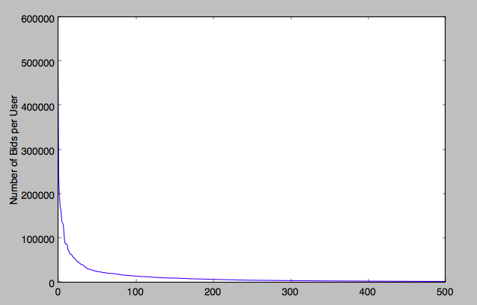

To go further into the exploratory analysis I found that there were a total of 15051 auctions for an average of 508 bids per auction. When I thought about the type of model I was going to use to predict the robots I thought it would be important to see the correlation between a bidder’s total number of bids and the number of auctions they’ve participated in. I’ve also looked into the ‘ip_address’ and ‘country’ field to see if those two fields can be helpful for determining a robot or not. I had an assumption that most robot bidders would come from countries that were less regulated and safe from these types of activities. There were 201 unique countries with the top 5 countries being India, Nigeria, Indonesia, Turkey, and finally the United States. I found this really interesting as most of these countries have a much lower GDP per capita than the US. This reinforces my hypothesis that robot bidders come from less regulated countries.

2 Predictive Task
Based on the research I’ve taken I will evaluate my model using a series of predictive elements such as the number of bids from a single bidder, the countries where robot bidding is most prevalent, and the number of bids of a single user per auction. I will be doing something to assignment 1 where I will have a variable threshold that I will adjust to fit the model and I compare my trained model with the test dataset.

Some relevant baselines that can be compared would be how the dataset included a sample submission csv file, which was really similar to pairs_Purchase.txt from Assignment 1. It contains the bidder_id and either a 0 or a 1 depending on whether or not that bidder is a robot. The baseline file assumed that all bidders were not robots and from the results had a 50% receiver operating characteristic (ROC). This ROC is the metric used to evaluate each data submission on Kaggle. Unfortunately for me, I was unable to utilize the Kaggle submission feature as the deadline had passed already. Instead I created my own way of comparing my model, which calculated the number of True Positives, True Negatives, False Positives, and False Negatives. It also calculated the True Positive Rate, the True Negative Rate, Precision (PPV), and NPV. These are all metrics used to figure out the receiver operator characteristic (ROC).

I was also curious about potentially using the ip address field and the country field of the bids to figure out if location can give me an additional model. From this I decided to develop a dictionary that contained all of the different countries and the number of times a bid was created in that country. I also took the training dataset and took the specific users who were classified as robots. I took these robot bidder ids and cross referenced it with the entire bid dataset to search for the country of these robot bidders. I made a list of those countries and compared it with my top 5 most active countries and trained my model to increase the threshold for possibility of a robot if they matched the country.

I did a lot of pre processing of the data since the bid dataset contained more than 7 million entries. I created a dictionary for the bidder and taking in all of their matching bids. I also created a dictionary that paired a specific bidder id with their countries that they have bid in.

The results of my exploratory analysis justified my assumption that robot bidders are from a certain set of countries and have a much larger number of bids.

3 Literature
The data from this Kaggle competition comes from an unnamed online platform and it is used for the competition. There was very little research in regards to machine learning and online auctions, so in order for me to understand how they work and come up with a model for prediction automated robot bidders, I did research on a similar topic: detecting online auction fraud. In one of these papers the author discussed the various possible predictive models that could be used in regards to this subject. Some of these models we’ve learned in class, such as Support Vector Machine (SVM) classification and Naïve Bayes. Other models included decision trees (DT), neural networks (NNs), and neuro-fuzzy inference (NFI). In this paper he discusses the various sample datasets which specific samples related to auction fraud behavior. This auction fraud behavior is similar to my dataset in that it contained three different types of data. In my dataset there was a controlled group of bidders who were for sure considered “bots”, a group of bidders who may have just started their accounts/or were outliers, and also a random control sample. In this paper, he continues to compare the results between five models and concludes that SVM performed the best in a full sample approach and gave me the idea to try and attempt the same model on my dataset.

Additional research of on online auctions led to me articles about consistent traits on how to identify robot bidders. Some of these characteristics include being able to make quick bids right before the end of an auction. This is difficult to figure out given the dataset that I have due to the fact that the time data is transformed to protect privacy. Robot bidders also have the characteristics of being automated and therefore can make multiple bids very quickly.
4 Results
The results of my integrated model have shown some slight improvements from the baseline model. There were a variety of feature vectors that I used to create my model, but combined they only incrementally improved my results. I found that it was much more accurate for me to limit the number of features I used in order to gain a greater improvement. With too much feature vectors, it was overfitting the data and increased the number of False Positive and False Negatives.

From the features that I used, looking at the most active bidders was most efficient because there was a large distinction between the top 50 active bidders and the rest of the 4000 bidders as shown from Graph 1. Table 1 shows the incremental results from the increase of my most active threshold variable. In regards to the geographical information that I proposed to use for the model, it was very helpful in increasing my likelihood of identifying the robot bidders.

Table 1. Most Active Bidders Effectiveness

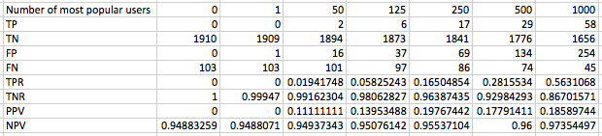

In conclusion, my model was able to improve the effectiveness of prediction by around ~8% through the use of my model. If I had more time I would have fully integrated the SVM model and added my features vectors and trained it using the training set. Other improvements I would have made would include splitting the bid dataset into two separate sets. The first set would contain around 30% of the data and I would train my model on that. Afterwards I would train another instance of my model on the 70% and compare the difference. This is sort of similar to what they would have done in the Kaggle competition. Overall, I’ve learned a lot about utilizing data mining techniques and models to figure out real world problems such as this. I’m glad that this assignment has pushed me to apply my small knowledge of Python in analyzing large datasets. I’ve learned to not always assume things as you would without the data and to just let the data speak for itself. I recognize the power of big data in today’s society as we evolve and become more technological dependent. More and more of our world is being recorded in virtual data which further pushes our need for data mining and machine learning to take advantage of that. From doing so, we could give insight to things we would not have otherwise known. Thank you for such as wonderful class, McAuley.

